**Air Temperature Controller**

**Final Year Project Mid-Evaluation**

Under the guidance of

**Prof. Somnath Pan**



Submitted By:

Kartik Hatwar – 20JE0414

Department Of Electrical Engineering

Indian Institute of Technology (Indian School Of Mines),

Dhanbad

**Contents**

1. Acknowledgement
2. Introduction
3. Block Diagram
4. Components
   * PID Controller
   * Heating Element
   * Temperature Sensor
   * Solid State Relay
5. Working of The System
6. Material Required
7. Software Circuit
8. Hardware Circuit
9. Conclusion

**Acknowledgement**

I would like to express my sincere gratitude and profound appreciation to my supervisor Prof. Somnath Pan who gave me this opportunity to work and who was a constant source of help and information, which helped me to proceed up until now with my work. The timely advices and guidelines have assisted me to get through a lot of difficult situations.

I am deeply indebted to the Electrical Department of Indian Institute of Technology (Indian School of Mines) Dhanbad for providing me with the necessary resources to help me with my project.

Finally, I would like to thank my batchmates for their assistance and my family and friends for their constant support and encouragement.

Kartik (20JE0414)

B. Tech. (Electrical Engineering)

Department of Electrical Engineering,

IIT (ISM) Dhanbad

**Introduction**

The control of air temperature is a critical aspect in various industries and applications, ranging from HVAC (Heating, Ventilation, and Air Conditioning) systems in buildings to industrial processes that require precise temperature regulation. As the demand for energy-efficient and environmentally friendly solutions continues to grow, the development of advanced air temperature controllers becomes increasingly relevant.

Traditional air temperature control systems often lack the flexibility and efficiency required to meet the evolving demands of modern applications. As a result, there is a growing need for innovative and intelligent temperature control solutions that can adapt to dynamic environments, optimize energy consumption, and ensure optimal comfort conditions.

The primary objective of this project is to design and implement an intelligent air temperature controller that goes beyond conventional systems. The controller aims to provide accurate and responsive temperature regulation, taking into account factors such as ambient conditions, occupancy, and energy efficiency.

The project scope encompasses the development of a temperature control system capable of maintaining a specified temperature setpoint in a given space. The system will utilize sensors to monitor the current temperature, and based on this information, it will control heating or cooling elements to achieve the desired temperature. Additionally, the controller will incorporate smart algorithms to adapt to changing conditions and optimize energy usage.

**Block Diagram**

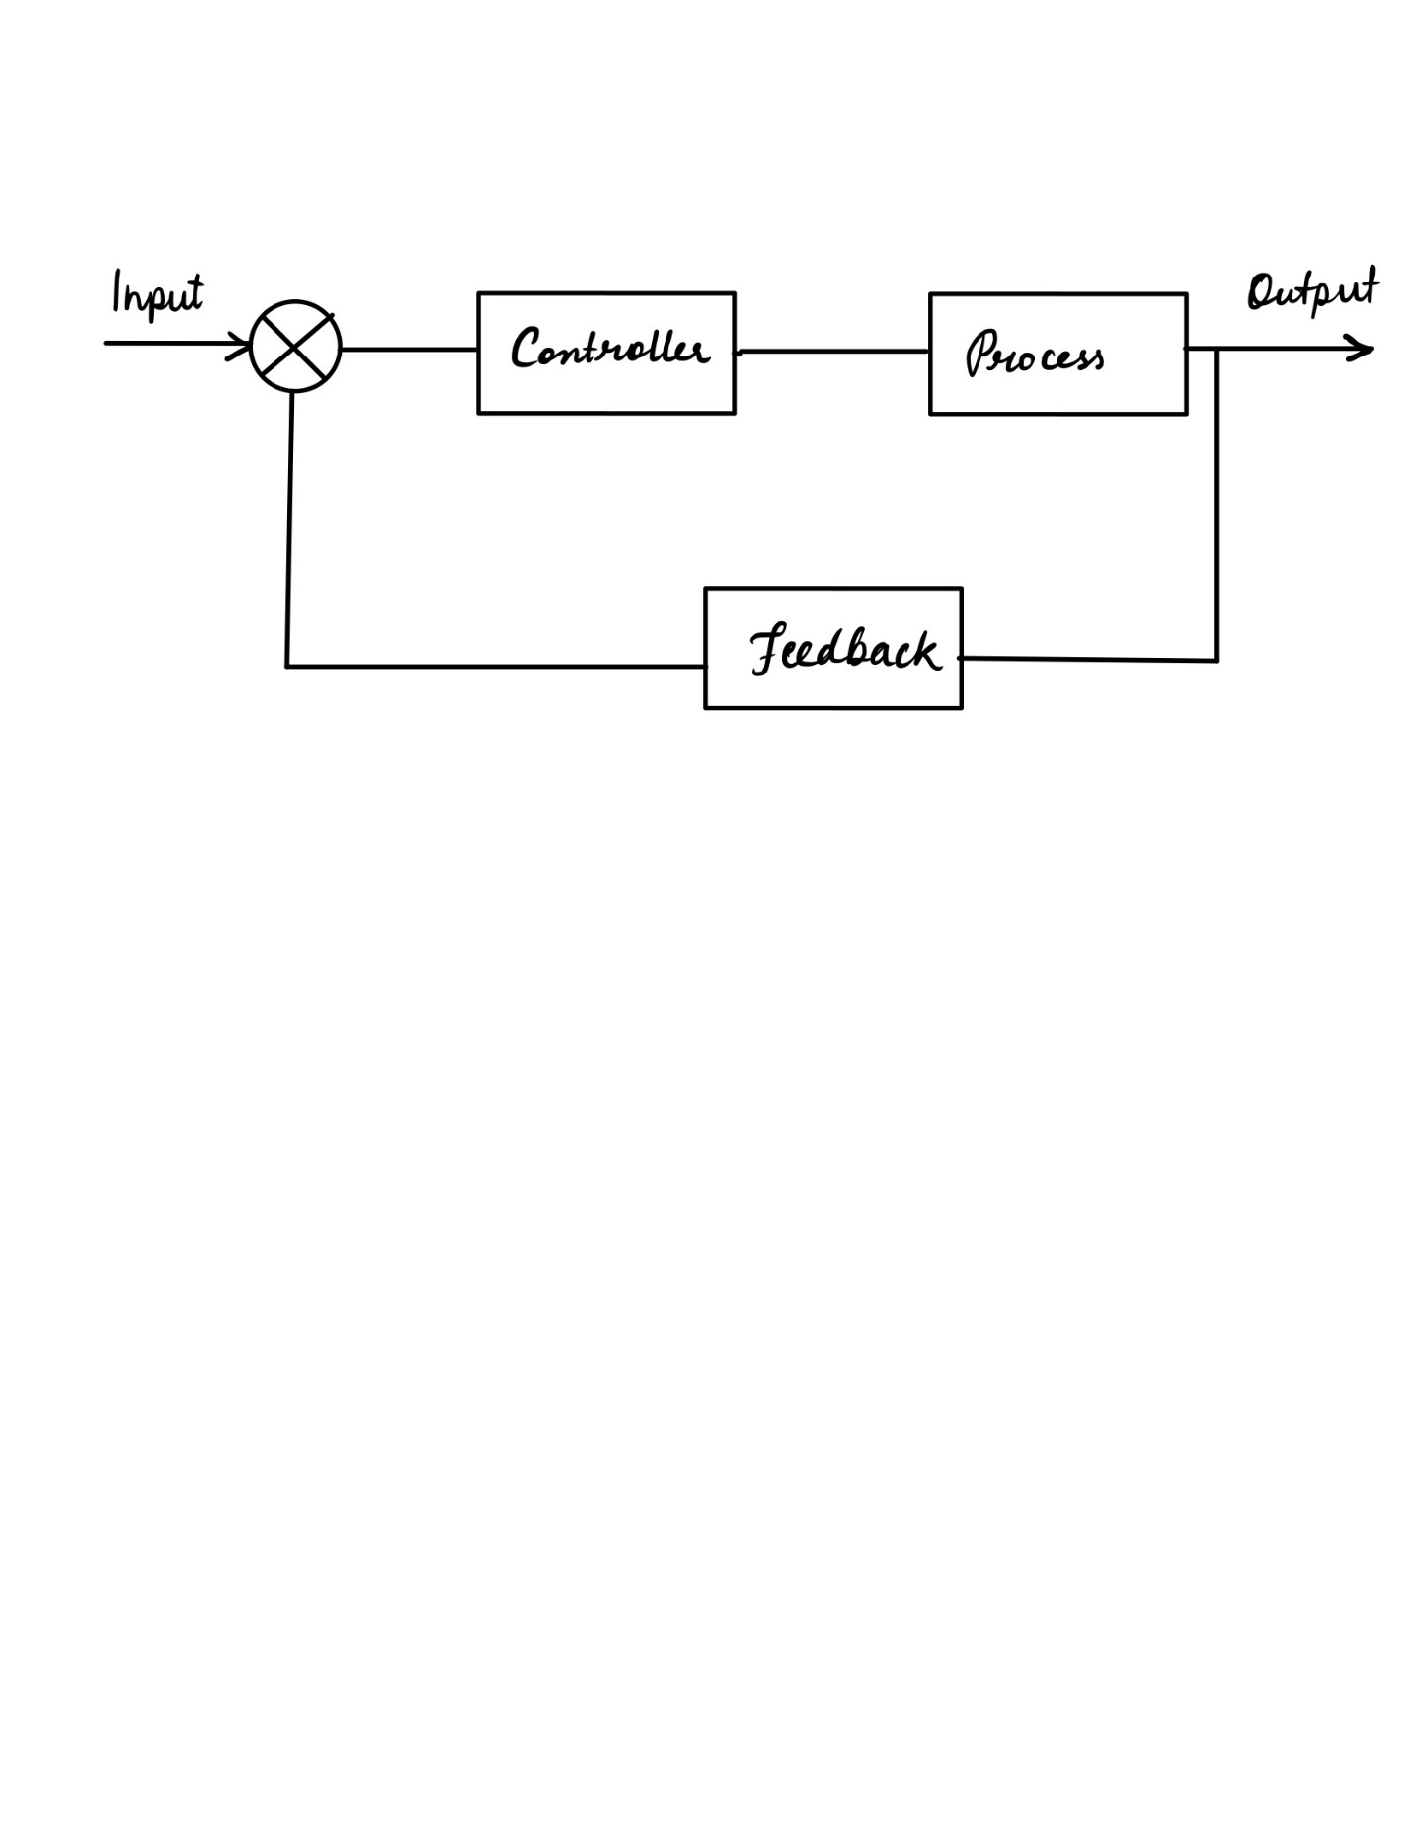

Blocks used are:

Controller : PID Controller

Process : Heating Element/Source

Feedback : Temperature Sensor

Whole blocks together form a close loop system of temperature control.

**Components**

Explanation for each blocks :

**PID Controller**

A proportional–integral–derivative controller (PID controller or three-term controller) is a [control loop](https://en.wikipedia.org/wiki/Control_loop) mechanism employing feedback.

Fundamental operation

The distinguishing feature of the PID controller is the ability to use the three *control terms* of proportional, integral and derivative influence on the controller output to apply accurate and optimal control. The block diagram shows the principles of how these terms are generated and applied.

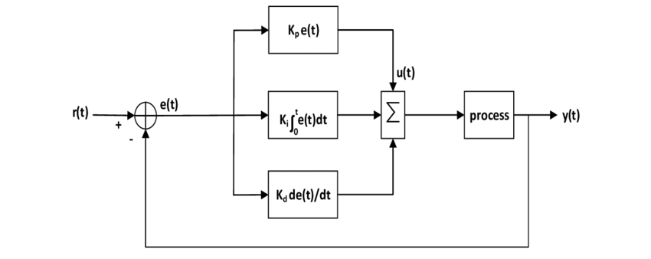

It shows a PID controller, which continuously calculates an error value **�(�)e(t)** as the difference between a desired [setpoint](https://en.wikipedia.org/wiki/Setpoint_(control_system)) **SP=�(�)SP=r(t)** and a measured [process variable](https://en.wikipedia.org/wiki/Process_variable) **PV=�(�)PV=y(t): e(t)=r(t)-y(t)** �(�)=�(�)−�(�), and applies a correction based on [proportional](https://en.wikipedia.org/wiki/Proportional_control), [integral](https://en.wikipedia.org/wiki/Integral), and [derivative](https://en.wikipedia.org/wiki/Derivative) terms. The controller attempts to minimize the error over time by adjustment of a control variable **�(�)u(t)**, such as the opening of a [control valve](https://en.wikipedia.org/wiki/Control_valve), to a new value determined by a [weighted sum](https://en.wikipedia.org/wiki/Weighted_sum) of the control terms.

Mathematical Representations of PID Controller Gains

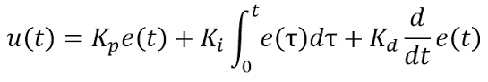

Response of PID Controller

In the graph below, the blue line represents the set value, and the purple curve, influenced by the proportional gain (Kp), shows system oscillations around the set point with overshooting. The green curve, introduced by the integral gain (Ki), eliminates steady-state error. The red curve, indicating the derivative gain (Kd), dampens oscillations, preventing an overly aggressive system response.

In summary, the proportional, integral, and derivative gains (Kp, Ki, and Kd) collectively contribute to the optimal functioning of the control system. The proportional gain addresses the immediate error, the integral gain eliminates steady-state error over time, and the derivative gain dampens oscillations, collectively working to achieve a stable and accurate response to changes in the set point.

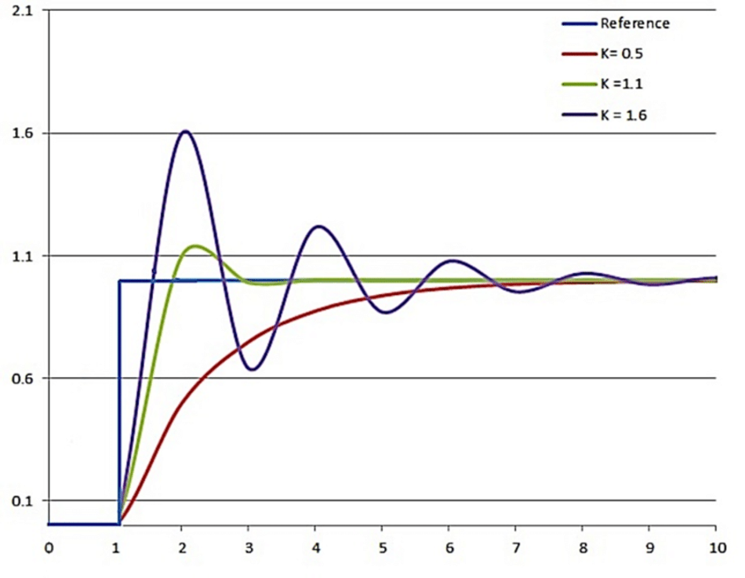

**Heating Element**

A heating element is an electrical device that converts electrical energy into heat through the process of [Joule heating](https://en.wikipedia.org/wiki/Joule_heating). [Electric current](https://en.wikipedia.org/wiki/Electric_current) through the element encounters [resistance](https://en.wikipedia.org/wiki/Electrical_resistance), resulting in heating of the element. This process is independent of the direction of current.

The material used for resistance heating elements should have high electrical resistance to facilitate efficient heat generation. Common materials include nichrome (nickel-chromium alloy), which is widely used due to its high melting point, corrosion resistance, and consistent resistance at high temperatures.

Resistance heating elements are often in the form of wires, coils, or ribbons. These elements are shaped to fit the specific requirements of the application. Coiling increases the overall length of the element, enhancing its resistance and, consequently, heat production.

The temperature generated by the resistance heating element can be controlled by adjusting the electrical power supplied to it. This control is crucial in applications where maintaining a specific temperature is essential.

**Temperature Sensor**

A temperature sensor is a device designed to measure the temperature of its surroundings and convert the temperature information into an electrical signal. Temperature sensors fall under the category of electronic devices. These sensors play a crucial role in various applications, from industrial processes to consumer electronics, providing essential temperature data for monitoring and control.

The one we are using in our system is RTD (Resistance Temperature Detector). An RTD is an electrical device that measures temperature by correlating the resistance of the RTD element with temperature. Here's a brief overview:

* **Principle:** RTDs operate on the principle that the electrical resistance of certain materials changes predictably with temperature. Typically, RTDs use a metal, such as platinum, as the sensing element.
* **Working Principle:** As the temperature changes, the electrical resistance of the RTD element changes proportionally. This change in resistance is then converted into a corresponding temperature value.
* **Accuracy:** RTDs are known for their high accuracy and stability over a wide temperature range.
* **Advantages:** High accuracy, stability, and linearity make RTDs suitable for demanding temperature measurement requirements.

RTDs are available in various types, depending on the material used for the sensor element and the tolerance class. The most common RTD types are platinum, nickel, and copper RTDs. Platinum RTDs are the most commonly used type of RTD.

There are 2-wire, 3-wire, and 4-wire RTDs; selecting which type to use depends on your temperature measurement requirements. In a basic 2-wire RTD, the circuit adds the resistance of the lead wires to the resistance of the RTD. This means the *read* temperature value is not exactly the *real* temperature value. Therefore, 3-wire RTDs have become the industry standard when greater accuracy is required.

**3 Wire RTD**

The three wire configuration provides a compensation loop that can be used to subtract the lead wire resistance from the resistance measurement of the element loop, resulting in a value for just the element resistance.

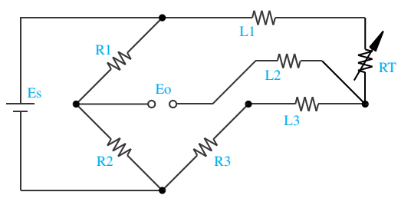

In this circuit there are three leads coming from the RTD instead of two. L1 and L3 carry the measuring current while L2 acts only as a potential lead. No current flows through it while the bridge is in balance. Since L1 and L3 are in separate arms of the bridge, resistance is canceled. This circuit assumes high impedance at Eo and close matching of resistance between wires L2 and L3.

**Solid State Relay**

A Solid State Relay (SSR) is an electronic switching device that controls electrical loads using semiconductor components without any moving parts. It is referred to as a "solid-state" relay because it relies on solid-state electronics (semiconductor devices) rather than traditional electromechanical components found in mechanical relays.

**Key Features of Solid State Relays:**

* Instead of using coils, springs, and mechanical contacts like traditional relays, SSRs employ semiconductor devices such as thyristors (SCRs), triacs, or power transistors. This solid-state design eliminates the need for moving parts, resulting in a more reliable and durable device.
* SSRs can switch on and off rapidly, often in microseconds, due to the quick response times of semiconductor devices. This fast switching capability is beneficial in applications where precise control is required.
* As there are no moving parts, SSRs experience minimal wear and tear. This characteristic contributes to their long operational life and high reliability.
* SSRs operate silently. This makes them suitable for applications where noise generation is a concern.
* SSRs do not produce arcing during switching, as there are no physical contacts to open or close. This reduces the risk of electrical wear and minimizes the potential for sparking.

**Difference from Static Relays:**

A Solid State Relay (SSR) is an electronic switching device that controls electrical loads using semiconductor components without any moving parts. It is referred to as a "solid-state" relay because it relies on solid-state electronics (semiconductor devices) rather than traditional electromechanical components found in mechanical relays.

**Key Features of Solid State Relays:**

1. **Solid-State Components:**
   * Instead of using coils, springs, and mechanical contacts like traditional relays, SSRs employ semiconductor devices such as thyristors (SCRs), triacs, or power transistors. This solid-state design eliminates the need for moving parts, resulting in a more reliable and durable device.
2. **Fast Switching:**
   * SSRs can switch on and off rapidly, often in microseconds, due to the quick response times of semiconductor devices. This fast switching capability is beneficial in applications where precise control is required.
3. **No Mechanical Wear:**
   * As there are no moving parts, SSRs experience minimal wear and tear. This characteristic contributes to their long operational life and high reliability.
4. **Noise-Free Operation:**
   * Unlike mechanical relays that may produce audible clicks during operation, SSRs operate silently. This makes them suitable for applications where noise generation is a concern.
5. **Optical Isolation:**
   * Many SSRs incorporate optical isolation, using light-emitting diodes (LEDs) to trigger the semiconductor switches. This ensures electrical separation between the control input and the load, providing added safety and protection against voltage spikes.
6. **No Arcing:**
   * SSRs do not produce arcing during switching, as there are no physical contacts to open or close. This reduces the risk of electrical wear and minimizes the potential for sparking.

**Difference from Static Relays:**

1. **Technology:**
   * Solid State Relays use semiconductor devices, such as thyristors or triacs, for switching. They rely on the principles of solid-state electronics.
   * Static Relays, on the other hand, use analog or digital electronic components without relying on semiconductor devices. They may use operational amplifiers, comparators, and other electronic circuits for control.
2. **Switching Mechanism:**
   * Solid State Relays switch loads using semiconductor devices without mechanical contacts.
   * Static Relays typically involve electronic circuits and no moving parts but may include electromechanical components for certain functions.
3. **Control and Sensing:**
   * Solid State Relays often incorporate optical isolation for control input and load.
   * Static Relays can include various electronic components for control and sensing but may not utilize optical isolation.

**Working of The System**

A temperature sensor is in contact with the heating element .The sensor continuously measures the temperature of the heating element.

The temperature sensor provides feedback to the PID controller, which continuously compares the sensed temperature (process variable, PV) to the desired setpoint temperature (SP). The PID controller calculates the error (SP - PV).

The PID controller processes the error using the proportional, integral, and derivative terms to determine the appropriate control output. The proportional term (P) responds to the current error, the integral term (I) addresses accumulated past errors, and the derivative term (D) anticipates future errors.

The output of the PID controller is connected to the input of a Solid State Relay (SSR). The SSR acts as a switch, controlling the power supply to the heating element. When the error is not zero, the PID controller adjusts the SSR to supply power to the heater, maintaining or changing the temperature as needed.

The heating element heats up when power is supplied through the SSR. As the temperature approaches the setpoint, the PID controller adjusts the SSR to reduce or cut off power, preventing overshooting. This prevents the temperature from exceeding the desired value.

If the temperature falls below the setpoint, the PID controller signals the SSR to reconnect the circuit, allowing power to flow to the heating element. This cycle of feedback, control, and adjustment continues, maintaining the temperature at the desired setpoint.

**Materials Required**

|  |  |  |
| --- | --- | --- |
| Item Name | Specification | Qty |
| Temperature Sensor | Type: PT-100, PT100 RTD Sensor 3mm 3 Wire 3 Meter Long Cable | 1 |
| Solid State Relay | FOTEK SSR-25DA 25A /250V 3-32V DC Input 24-380VAC Output | 1 |
| PID Controller | Make: Radix,  Model- NEX 301 | 1 |
| Electric Heater Coil | 400 W | 1 |
| Wires | - | - |

**Software Circuit Diagram (Ideal)**

**Circuit Diagram**

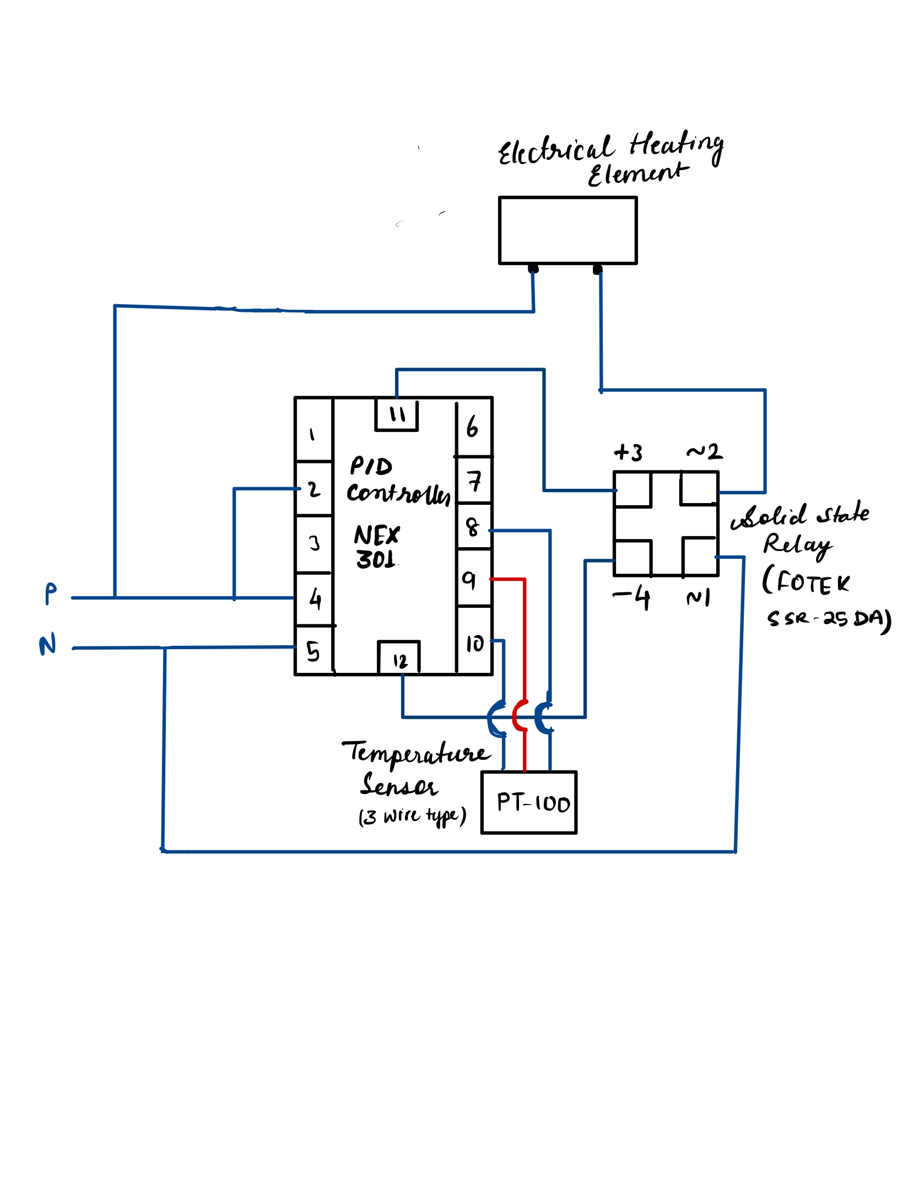

PIN-Out diagram for the PID Controller (NEX 301)

Pin 4 & 5 are for power supply.

Pin 8, 9 & 10 are input pins to take input

from RTD .

Pin 11 & 12 are output pins for control,

and connected to the SSR in our system.

**Conclusion**

The air temperature controller model, incorporating a PID controller, solid-state relay, heating element, and temperature sensor, provides a versatile solution for precise temperature regulation. The PID controller's proportional, integral, and derivative components balance stability and responsiveness. The solid-state relay efficiently controls the heating element, and the temperature sensor provides vital feedback for continuous adjustment.